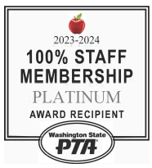
January Maple Hills PTA Newsletter:

Happy New Year

The Chirp!
Dear Maple Hills Families,

We are thrilled to announce that the Maple Hills PTA Auction will be held on May 2nd, 2025!
The auction is one of our school’s most significant fundraising events, directly benefiting our students and programs. Your participation and generosity are crucial to its success.

How You Can Support the Auction:
- Donate Items or Experiences
Do you have a talent, service, or item that would make a fantastic auction lot? Vacation Rentals/Homes, handmade crafts, gift certificates, event tickets, or unique experiences are all welcome! Every contribution makes a difference.
  - Submit your donations here: https://maplehillspta.ejoinme.org/donations
- Contribute to Classroom Gift Baskets
Each grade will create themed baskets for the auction, and donations are key to bringing these to life. The classrooms with the most donated will win a Donut and Pajama Party!
  - Classroom Basket Info: https://maplehillspta.com/Page/Auction/Classroom%20Baskets
- Sign Up to Attend
Mark your calendars for a fun evening of bidding and supporting our school community on May 2nd!
  - Purchase tickets here: https://maplehillspta.ejoinme.org/tickets
- Volunteer
We need your help with procurement, decorations, and event-day logistics. Please email us at volunteers@maplehillspta.com to join the team.
Get Involved Today:
- Donate or purchase tickets at: https://maplehillspta.ejoinme.org/80sNightAuction
- Have questions? Contact us at auction@maplehillspta.com.
Your support and involvement are what make this event special. A tremendous amount of time and effort goes into ensuring the auction is not only a successful fundraiser but also a memorable community event. We are so grateful for your generosity and participation, and we can’t wait to see you there!

Thank you for helping us make a difference for our students!
Sincerely,
Heather Stiles
Maple Hills PTA President, 2024–2025
President@maplehillspta.com

Important Dates
 | January 22  -Variety Show Applications Due  -PTA General Membership Meeting 7:00pm | January 31  Report Cards Available
 | January 24  MH at the Thunderbirds | February 5  Variety Show Dress Rehearsal
 | January 27  NO SCHOOL - Teacher Work Day | February 11  Eagle Reader Clubhouse
 | January 29  Variety Show Auditions | February 17-21  NO SCHOOL – Mid Winter Break
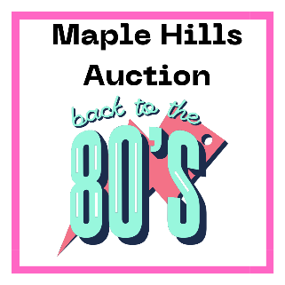  Tickets On Sale Now!  We still need your help to make this event a success!  Donations Needed: Gift cards, event tickets, unique experiences, and more!  Sponsors Wanted: Showcase your business while supporting our school.    Volunteers Needed: Help with planning, setup, or event day support.  Buy your tickets and get involved: |  |  |  | Reflections Art Contest  Thank you to all the talented Maple Hills students who submitted their amazing Reflections entries this year; while we did not have any finalists move on, we are so proud of your creativity and the heart you put into your work!  Scan the QR Code to see our students’ amazing work.  
Volunteers Make It Happen!
If you would like to volunteer or have any questions, please email volunteers@maplehillspta.com or onetimeevents@maplehillspta.com
To see more opportunities to help.
Volunteer Central:


Thank You for Supporting Maple Hills PTA Fundraising!
Your contributions to our PTA fundraising campaigns make a real difference for our students and school! A huge thank you to all the families who have participated so far—we couldn’t do it without you.
Here’s what you’ve helped us achieve:
- Eagle Spirit Wear (with Mossy Trail): Both Sale Periods $1,959.87
- Dave & Buster's Power Cards: Sold 23 cards, raising $212.78
- Regal Fundraising Bundles: Sold 18 bundles, raising $114.57
- Brown Bear Car Wash Tickets: Raised $585.00
- Poinsettia Sales: Raised $1,070.00
Looking ahead, our Annual Auction on May 2nd is our main fundraising effort. This event is crucial for supporting PTA programs, events, teacher grants, and so much more. We encourage all families to get involved by donating, sponsoring, or attending the event.
Thank you for being part of the Maple Hills family and for helping us build a stronger, more vibrant school community!

PTA Membership Renewal
Must be renewed yearly to be a member

Becoming a member does not require you to be a volunteer.

